**The ‘one size fits all’ public service model: is it fit for purpose?**

**Kevin Callinan, Senior General Secretary Designate, Fórsa**

**IRN Conference 2019, 7th March 2019, Irish Management Institute**

Any discussion of public service pay agreements must be rooted in the value they bring to their various stakeholders. For trade unions and our members, this is measured in their ability to protect and improve jobs, incomes and working conditions.

We also value the broader contribution they have made in terms of fiscal sustainability, social stability, and the certainty they bring to the provision of public services. This fundamental contribution, to society and the economy, has also been recognised, explicitly or implicitly, by a very wide range of economic, governmental and societal actors, in good times and in bad, for well over a quarter of a century.

Included among them are major political parties of virtually every hue – certainly once they are in government and responsible for sustaining that certainty and stability – and, in darker times, by the Troika, which never seriously questioned the value of the Croke Park agreement, even when it became received wisdom among commentators that the deal could not survive the bail-out and the economic adjustment that followed.

This long-standing support for our effective approach to public service pay and IR has rested, in large part, on its capacity to change direction when the fiscal or industrial circumstances demanded it. Sometimes this has happened gradually; other times – as we’ve experienced in the last decade – it has been drastic, sudden and painful.

I believe it is now time for another change in direction.

Before I develop that point, I want to interrogate the phrase ‘one-size-fits-all’ in the title of this session. I think this is misnomer, which has become imbedded because the headline pay increases in public service agreements have often – though not always – been of ‘one size’.

While it is true to say that all public servants were subjected to the FEMPI measures together, the fact is that we have not had – and do not have – a ‘one-size-fits-all’ model.

This is historically the case. And, in recent times, public service agreements have seen significant changes in the treatment of pensions, pay, and working conditions, many of which have applied in quite different ways across the public sector workforce.

For example, the Haddington Road Agreement included temporary pay cuts for higher-paid staff, which didn’t apply to others.

It also included (what the official side sees as permanent) increased working time for very many – though not all – public servants. This is an issue that still rankles, and which can and must be addressed, not least in the context of broader debates about working time as new technologies impact on work practices and employment.

Throughout the crisis period and after, agreements included many other measures intended to eliminate, contain or obviate costs, which impacted on sectors and grades, groups and categories of workers in sometimes radically different ways.

Most recently the PSSA introduced the distinction between covered and non-covered public servants, though this has failed to make a telling impact on the conduct of industrial relations.

Workers accepted – rather than welcomed – many of these measures because they were convinced of their necessity. But if those bound by an agreement are no longer convinced of its intrinsic merits – of its fairness, of the necessity of its measures, and of the mutuality of its obligations – then trouble is inevitable.

When the credibility of the process is stretched – for one or more of its many stakeholders – the model itself becomes strained, and instability follows. We have seen this in the past: The PCW grade claims of the late 1990s; benchmarking; the crisis cuts of 2009 and early 2010; the fallout from the 2016 Garda Labour Court recommendation; even, I would argue, the experience of Croke Park II (which failed to win the support of a majority of union members) and some of the measures contained in the Haddington Road Agreement.

Now, the credibility of the current agreement is being stretched by two important factors, which have taken root over the last decade, and which now need to be addressed. One is the spending power of incomes after living costs are factored in; the other is the scope for the agreement to respond to profession-specific and grade-specific issues and ambitions.

This means that a paradigm shift, involving a greater recognition of the generalised loss of spending power, and the need for a mechanism to review individual grades, groups and categories, is urgently required. Otherwise a raft of relativity, productivity and change-related claims – and the potential for industrial unrest that, historically, has accompanied them – seems almost certain.

The important distinctions between workers’ different experiences of recent agreements, which I have mentioned, complicate the process, and can lead to differences of emphasis between trade unions. But all the grievances I hear, in workplaces and union meetings, are connected by one thing – the failure of incomes to match the rising cost of living over the last decade.

It will simply not be credible to seek to continue on the current course without a correction to this.

The extent to which public servants have suffered reductions in take home pay is discussed, though it’s often insufficiently understood or acknowledged. But the lack of compensation for inflation over the last decade goes entirely unremarked.

Meanwhile, the absence of a process that allows individual groups to advance arguments regarding changes in their roles, responsibilities and working experiences, has fuelled grievances. The recent recognition – by both the Government and the Labour Court – that the PSSA is to some extent capable of dealing with this could herald a positive change in direction on this issue.

The recent nurses’ strike was a symptom of a wider frustration. Like many others, staff working in a dysfunctional system, often in appalling conditions and under intense pressure, were really challenging the significant loss in spending power experienced over a decade, although their case may have been expressed in various ways.

I don’t want to pre-empt the outcome of a process – including a ballot – that is incomplete. But the Labour Court recommendation is instructive. Although it left nurses’ starting salaries unaltered, the recommendation would see newly-hired nurses achieve a substantial pay increase in a relatively short period of time.

One has to assume that this is in recognition – at least in part – of the very real difficulties involved in trying to live on starting incomes significantly reduced by measures imposed on new hires in 2011.

As public sector recruitment has gathered pace, more and more workers are affected by such measures – and there are many cases where the starting pay is a lot lower than in nursing. These lower entry rates and the pace of scale progression should be urgently – and more widely – reconsidered.

Brexit notwithstanding, the economic conditions mean we are in a position to do this. Ireland remains a low tax country and, while the gap between the Irish tax-to-GDP ratio and the OECD average is widening, tax receipts are now well ahead of pre-crash levels.

The European Commission forecasts Irish growth at 4% this year and next, following real GDP growth of around 7% in both 2017 and 2018. Progress towards the 60% debt-to-GDP ratio is well advanced, and compliance with the Medium Term Budgetary Objective has been achieved. All this while paying over 5 billion euro in interest on State debt.

Meanwhile, unemployment has fallen steadily and the January 2019 Live Register showed joblessness at its lowest seasonally-adjusted level since April 2008. The graph from 2013 to 2019 closely resembles that from 1993 to 1999.

**Tax-to GDP ratio over time**

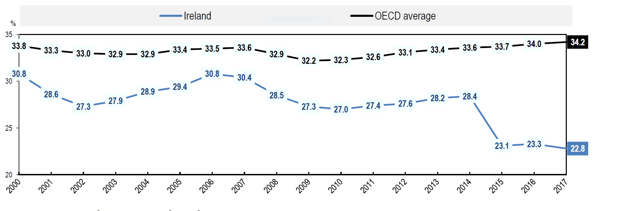

**Tax-to-GDP ratio compared to the OECD, 2017**

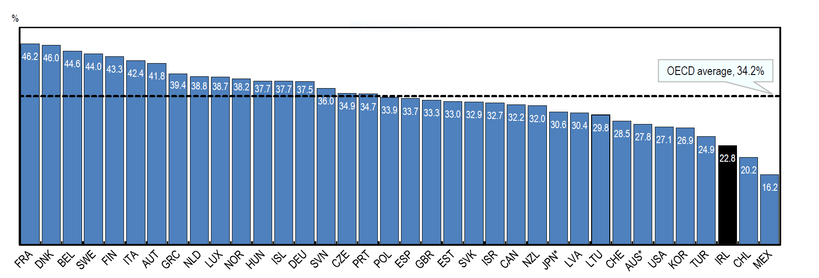

Source: OECD

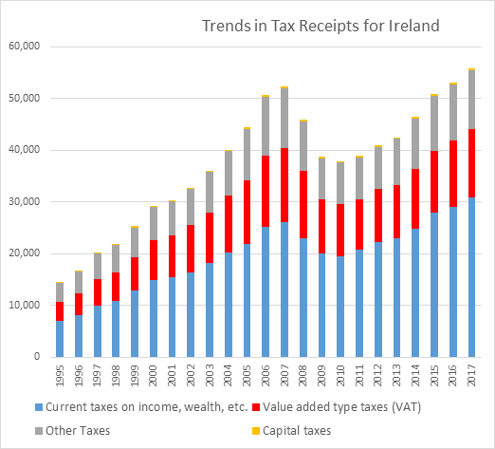

Source: Eurostat

These impressive trends are feeding into wage improvements. The Chartered Institute of Personnel and Development’s most recent Labour Market Outlook forecast private sector basic-pay growth of 2.5% this year, while the Congress private sector committee has urged affiliate unions to seek wages rises of at least 3.4% - and more in profitable areas of the economy. This is in line with Central Bank wage growth predictions of 7% across the economy in the two-year period, 2019 to 2020.

In normal times, public sector unions’ pay bargaining strategy would be guided predominantly by settlements in the private sector, and the need to achieve improvements in the real incomes of members. Clearly the current situation is complicated by the austerity measures introduced in the five years from 2009 to 2013. Along with the increase in working time that I mentioned earlier, these included:

* Substantial pay cuts, which have not yet been fully restored;
* Significantly increased pension contributions, the bulk of which remain in place;
* Reduced pension payments, though these are now being restored;
* The increased taxes and charges, including the USC, which applied across the economy;
* New arrangements for new entrants;
* The halving of sick leave arrangements;
* The introduction of a new Single Public Service Pension Scheme with inferior benefits – its membership now numbers in the tens of thousands;
* The loss of allowances which, for some, made up a significant part of income;
* The introduction of a raft of cost-saving productivity measures that have impacted on working conditions;
* And the absence of the mechanisms, which existed in previous agreements from Programme for National Recovery to Sustaining Progress, to implement outstanding pay awards, review pay grades, or reward enhanced responsibility and improved productivity.

All this in a period where public service provision quickly became much more demanding because of the impact of the crisis on demand – and all on top of an exponential growth in the size of the population over the last 20 years, with all the challenges this brings.

Meanwhile, our historically low inflation levels have drawn attention away from the fact that the spending power of wages has been eroded by prices over the last decade.

The December-to-December CPI figures show a cumulative increase of over 6% between 2009 and 2018, even allowing for a negative or zero level in some years.

And it is also worth noting that CPI is a crude-enough measure of living standards and spending power. The figure of 6% inflation over a decade may well resonate with a middle-aged couple in secure jobs whose mortgage is paid and whose kids have finished their education. But it doesn’t tell us much about the reality facing young workers starting out in life.

The CSO data on average earnings, hours worked and labour costs, published last month, is also revealing – particularly if you compare the results for the total workforce with selected sectors comprising a strong public service bias. The table below seeks to do this.

You’ll see that the very significant rise in unemployment from 2008 until 2014 appears to have had little, if any, impact on average private sector earnings. So, provided they didn’t lose their job – and that’s a significant caveat – private sector workers don’t appear to have experienced pay cuts, although incomes were negatively affected by increased taxes and charges.

Indeed, when account is taken of the steep reduction in public sector earnings during the same period, it would appear that private sector earnings actually rose.

The calculations in italics represent an attempt to compare the latest data with the first quarter of 2008. The average hourly earnings in the education sector looks like an outlier, perhaps reflecting a failure to record additional working time in schools.

Nonetheless, the other sectors demonstrate the effect of increased working time on hourly earnings. It’s also clear that sectors with a high public service component are behind the overall economy in terms of growth in average earnings, and this difference will be further emphasised when allowance is made for the depressive effect of the public sector element on the overall average.

**CSO average earnings, hours worked, employment and labour costs by selected sectors**

|  |  |  |  |  |  |  |
| --- | --- | --- | --- | --- | --- | --- |
|  | **2008 Q1** | **2011 Q1** | **2014 Q1** | **2017 Q1** | **2018 Q4** |  |
|  |  |  |  |  |  |  |
|  | **Overall Workforce** | | | | | |
| Employment | 1,767,200 | 1,478,700 | 1,535,300 | 1,740,900 | 1,868,100 | *105.71%* |
| Average weekly earnings | 704.60 | 684.87 | 699.67 | 725.12 | 761.65 | *108.81%* |
| Average hourly earnings | 21.56 | 22.18 | 20.89 | 22.27 | 23.46 | *108.81%* |
|  |  |  |  |  |  |  |
|  | **Public administration and defence, compulsory social security** | | | | | |
| Employment | 118,500 | 113,900 | 107,000 | 112,900 | 130,700 | *110.29%* |
| Average weekly earnings | 961.47 | 918.85 | 920.92 | 922.84 | 955.42 | *99.37%* |
| Average hourly earnings | 27.78 | 25.94 | 25.55 | 25.31 | 26.07 | *93.84%* |
|  |  |  |  |  |  |  |
|  | **Education** | | | | | |
| Employment | 133,600 | 129,200 | 134,700 | 146,000 | 165,000 | *123.50%* |
| Average weekly earnings | 838.72 | 831.49 | 802.18 | 801.06 | 861.13 | *102.67%* |
| Average hourly earnings | 33.75 | 35.96 | 34.35 | 33.70 | 36.27 | *107.46%* |
|  |  |  |  |  |  |  |
|  | **Human health and social Work** | | | | | |
| Employment | 206,000 | 211,800 | 219,400 | 235,800 | 248,300 | *120.53%* |
| Average weekly earnings | 711.18 | 717.64 | 667.76 | 690.23 | 729.20 | *102.53%* |
| Average hourly earnings | 23.10 | 23.56 | 22.35 | 22.29 | 23.13 | *100.13%* |

*the figures in italics in the final column are the 2018 Q3 figures expressed as a percentage of the 2008 Q1 ones. Source: CSO

Like all workers, public servants deeply resent the suggestion that they were responsible for the crisis. I am indebted to my colleague Michael Taft of SIPTU who, in a blog last month, reminded us that the crash came about because “exchequer finances were exposed by banks recklessly over-extending themselves, exploiting a speculative property sector,” and that this led to a collapse in construction employment compounded by a fiscal policy that had “tied tax revenue to property-related tax receipts while cutting every possible tax (corporation, inheritance and capital gains, income, stamp duties, etc).” Taft also notes that public employee compensation fell from 13.5% of GNI* in 2008 to 11.2% in 2018.

But it is time to move beyond the language of crisis – even the language of restoration – which, despite the sound economic and fiscal indicators I have referenced, remain a strong element in the lexicon of public service industrial relations.

The Public Service Pay and Pensions Act, which gave legal force to the PSSA, is designed to deliver pay restoration, increases in pension payments, the repeal of the 2009 FEMPI Act, and other improvements. Yet its preamble is couched in the language of crisis, economic vulnerability, debt, uncertainty, and reductions in pay and pensions.

It’s time to move on from this emergency precept. Notwithstanding the challenges that Brexit presents, the continued use of this language - more than ten years since the onset of the crisis, and in a time of impressive growth and tumbling unemployment – further stretches the credibility of the PSSA.

There are lessons to be learned from yesterday, but it is time to shift our focus from the past and focus on the challenge of delivering real improvements in wages and purchasing power. By way of comparison, German public service employers and union have just agreed a three-year pay deal that comfortably outstrips inflation.

Furthermore, it is simply no longer possible to refuse workers the periodic opportunity to make the case for their own grade or profession; to robustly – and fairly – test the validity of their arguments, be they based on increased productivity, changes in relativities, enhanced qualifications, additional skills, or added responsibilities.

It’s now almost 20 years since public service workers had that opportunity – 20 years that have seen enormous changes in roles, responsibilities and working practices.

The Labour Court has now recognised this in the case of nursing, and has recommended a review of the profession, which it linked to the wider public service review previously recommended by the Public Service Pay Commission. Other grades and professions who aspire to participate in such an exercise will expect similar treatment in the same timeframe.

This would go a long way in restoring confidence in the PSSA, whose underlying assumptions also need to be reviewed to take account of inflation, the exceptional growth of 2017 and 2018, and pay movements in the wider economy. Such an approach could frame the negotiations on a successor to the current agreement, which will have to be sufficiently flexible to pair general increases, designed to protect living standards, with progress on specific grade or profession reviews.

We want to restore and maintain full confidence in the PSSA, and our model of public service pay determination. Unions have been assured that DPER will continue to engage, including on the broader implications of the recent Labour Court recommendation. This engagement must now urgently address any changes in the assumptions underlying the PSSA, as is allowed under clause 8.4.2 of the agreement.

The union expects these engagements to continue to take place over the coming weeks with the objective of ensuring the continued effectiveness and stability of the public service agreement, and to ensure that it remains ‘fit for purpose.’

ENDS

________________

A footnote on social dialogue, Europe and public services:

The absence of effective tripartism was evident in the run up to and during the nurses’ strike. Social dialogue, if it is to be worthwhile, needs to be more than just consultative. It must be ambitious enough to tackle the big issues. When Brexit is settled people will look to why we chose to remain part of the EU. If Europe is seen to be about economic governance rules that depress your cost of living while the wealthy prosper it will soon lose popular support. A fresh vision for Social Europe is required that will underpin genuine social dialogue, effective collective bargaining, real measures to tackle inequality and quality public services.

At an Irish level that requires an ideological shift. Once and for all we need to address the dysfunctionality that is the inevitable consequence of our public/private health system; we need to reverse the decision to leave the early care and education of our children to the market; we need to ensure adequate occupational pension coverage in the private sector; we need to start building public housing again; and we need to invest strategically in higher education and further education and training.

Strangely enough, if we had a world class, cutting edge health service, affordable high-quality childcare and a well-funded, innovative education system, there is every chance that we would retain a highly motivated workforce in our public service rather than training so many to seek opportunities elsewhere or to find work in different careers. That kind of vision could, if delivered, play a key role in moderating pay demands and expectations.