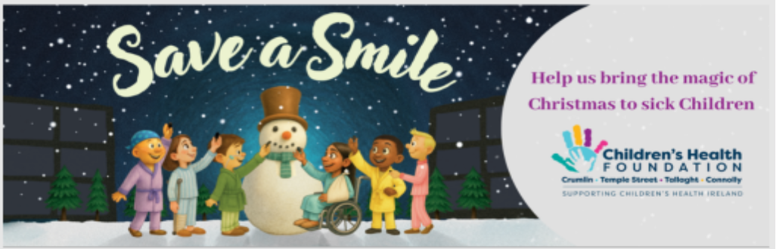

Thank you for considering donating toys to save a smile for children in Hospital this Christmas.
Visit our website to learn more about how to save a smile this Christmas.

If you are generously donating by cheque, please ensure all cheques are made out to ‘Children’s Health Foundation'. We cannot accept cheques made out to individual hospitals.

Children’s Health Ireland is a clinical environment therefore any kind offers of gifts need to be aligned with their Health and Safety policies. All toys need to be:
- New
- Unwrapped
- Latex Free
- Display the EU CE safety label
- Toys depicting violence or war paraphernalia will not be accepted.
- Console games are regulated using the European PEGI rating system.
- We cannot accept any games rated 16 or 18 on the PEGI system.

Please consider gifts for all ages, especially young adults up from ages 14 -18.
Vouchers are extremely welcomed, as they can be provided to families most in need.

Hospital Wish List
Games:  30 Second Rule  Chinese Checkers  Blokus  Advanced Word Finds  Would You Rather  Catch Phrase  Scrabble  Bananagrams  Deluxe Uno  Ticket to Ride  Themed Monopoly  Say Anything  Chess  Speak Out  Story Cubes  Jenga  Connect 4  Dobble  Headbandz  Guess Who  Jigsaws (All Ages) | Arts and Crafts:  Scrapbooking sets  Art Canvases & Acrylic Paint Sets  Advanced Jewellery-making Kits  Model Car Kits  Adult Colouring Books  String Art Kits  Sketch books  Playdoh  Dimond Art  Tie-dye kits  Stickers  Sticker books  Water colour paint sets  Ceramic Paint sets  STEM kits for older children to build and create!
Lego: All ages, very popular!  Creator  Technic  City  Friends  Juniors | Dolls: (all skin tones and types)  Baby dolls  My Generation dolls  Barbies  My Little Pony  Disney  Figurines from Popular Shows  Accessories
Imaginative Play Toys:  Tea Sets  Kitchen Sets  Play Food  Medical Play Kits/Doctors Kit  Vet Kits  Garages  Playhouses  Figures  Animals  Farm sets | Cars/Trucks:  Hot Wheels  Tractors  Construction Trucks  Remote Cars  Racetracks  Train Sets
Soft Toys:  Teddies  Squishmellows  Stuffed Animals  Soft Blankets  PJs  Slippers  ***All must be new and unopened | Books:  Board Books for infants/toddlers  Colouring books  Activity books  Sticker books  Picture books  Popular Books for teens and school age!
Baby/Toddler Toys:  Light up toys  Musical toys  Sensory toys  Rattles  O-Balls  Soft Balls  Fisher Price  Leap Frog  Blocks  Play Gyms  Bath Toys  Sensory Toys  Mirror Toys  Push Toys | Vouchers:  *Great for adolescents!  Smyths  Eason’s  One for All  Penny’s  Tesco  Decathlon  Thinking Toys  Amazon.ie
Sensory Items:  Sensory toys/items  Fidgets  Light projectors  Bluetooth speakers  Slime kits  Kinetic sand  Musical items | Adolescent Specific:  Selfcare Kits  Makeup  Soap Sets  Deodorants/Body Sprays  Bluetooth speakers/headphones  Ring lights  Makeup mirrors  PJs  Slippers  Fun socks  Sports equipment

